# MongoDB -Aggregation Exercises

Import the zips.json file into your MongoDB. Database name is "population" and collection name is "zipcodes".

mongoimport --db population --collection zipcodes --file zips.json

# Atlanta Population

1. use db.zipcodes.find() to filter results to only the results where city is ATLANTA and state is GA.

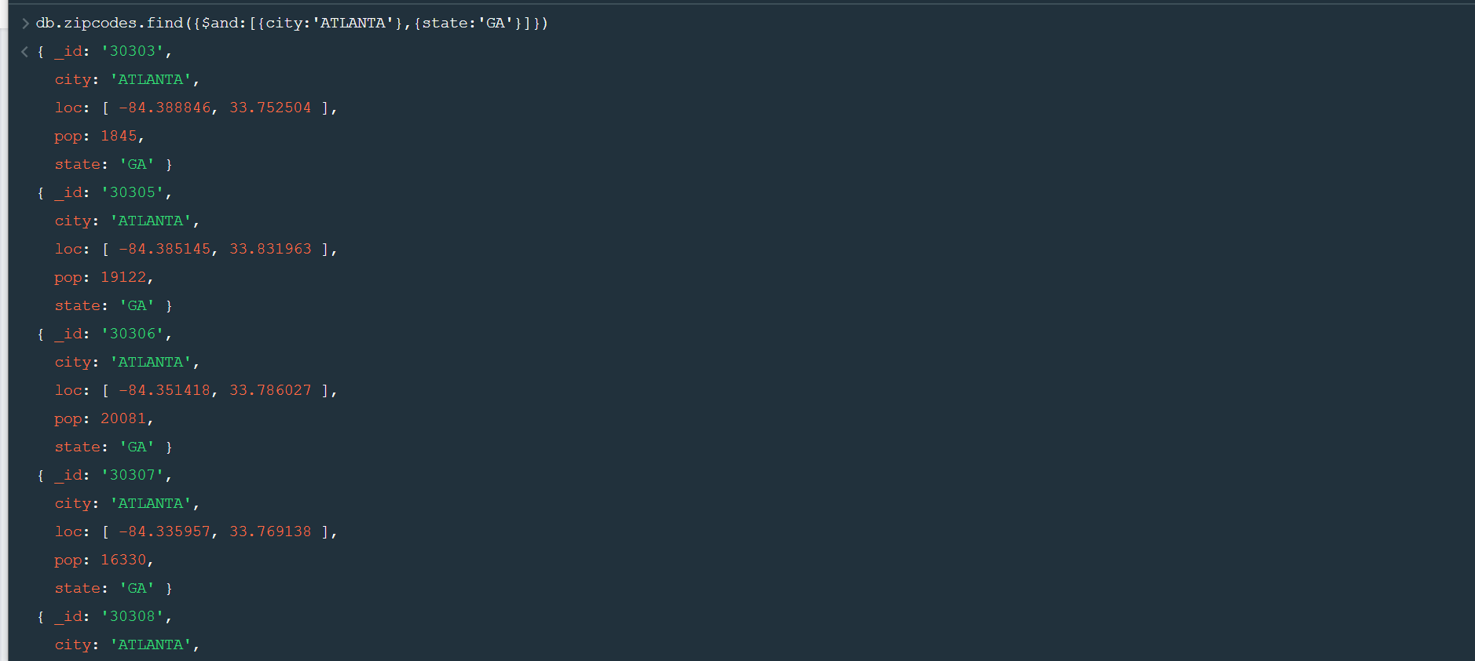

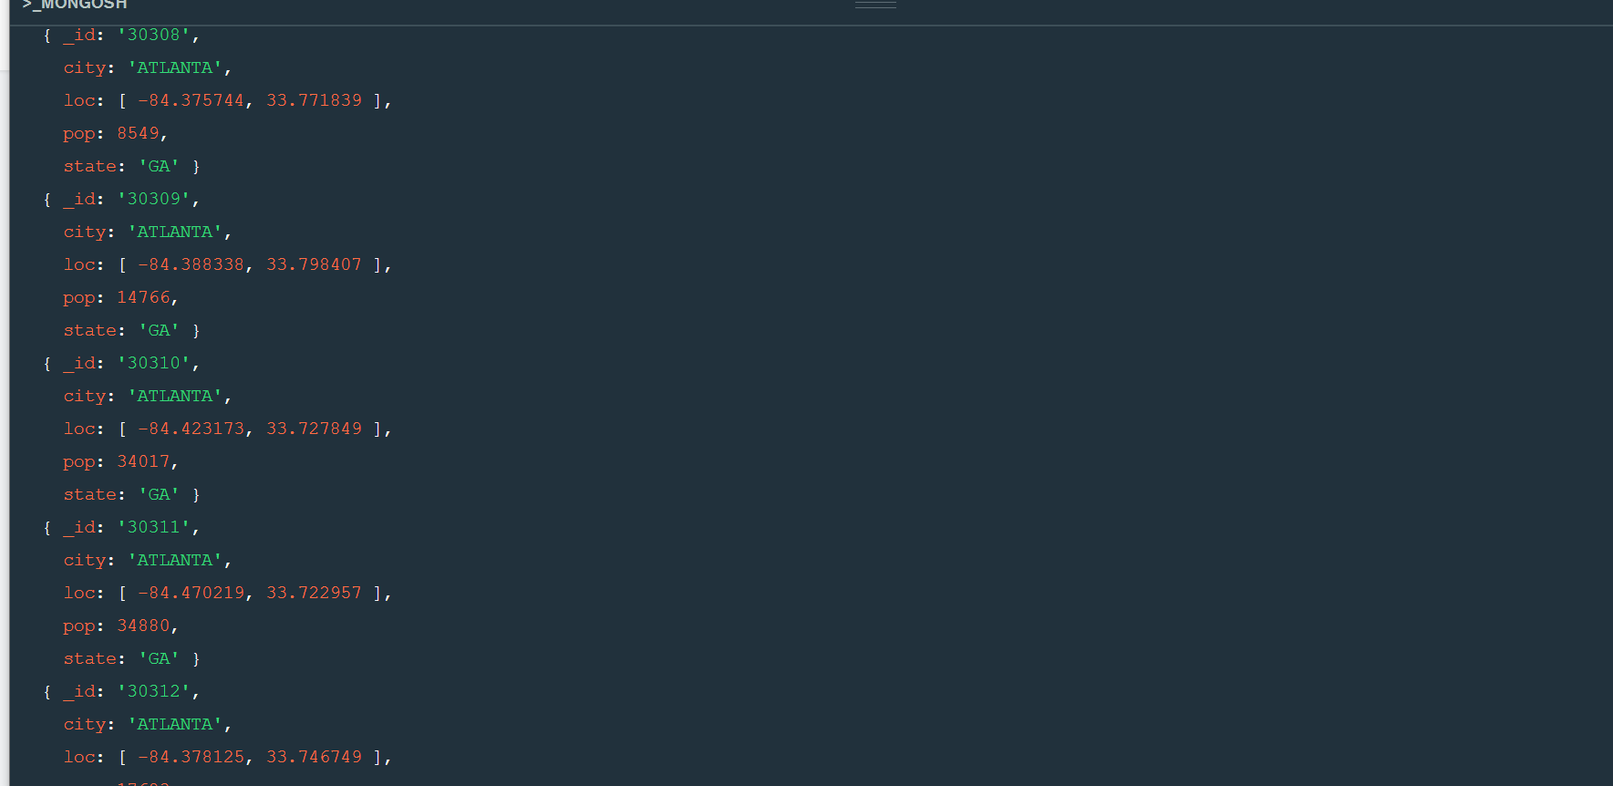

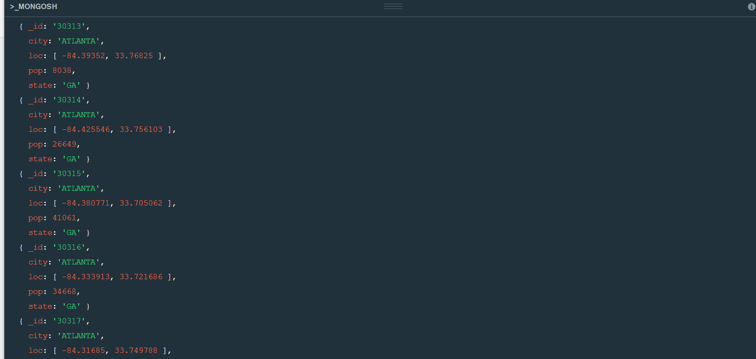

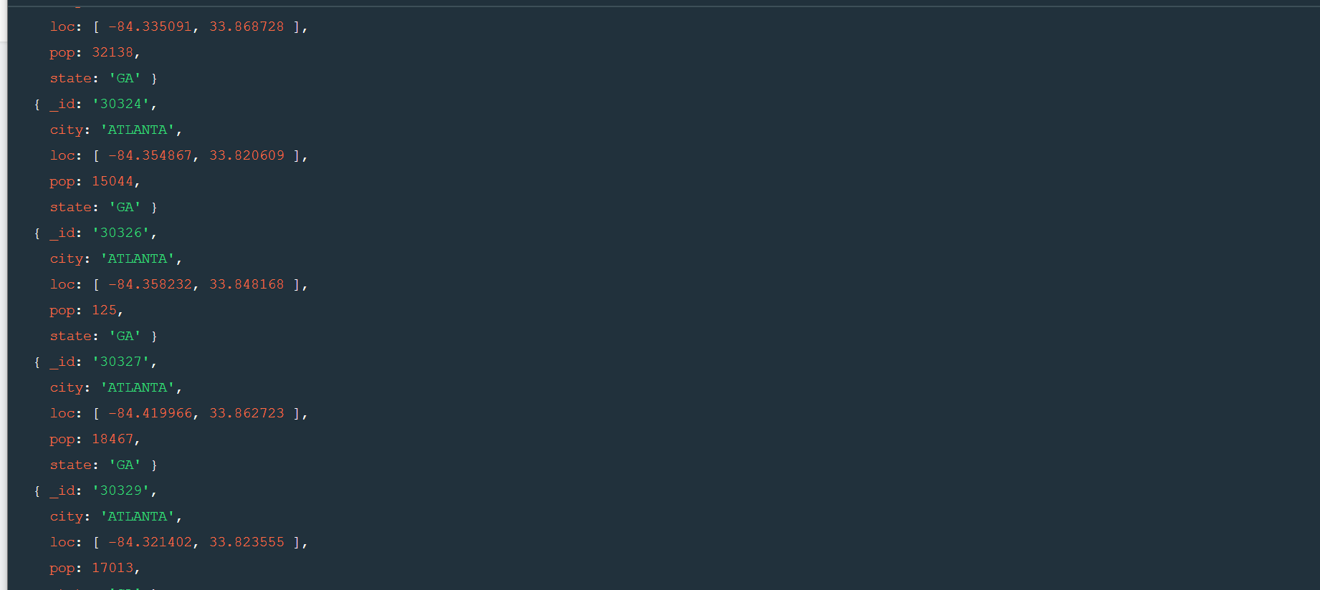

1. use db.zipcodes.aggregate with $match to do the same as above.

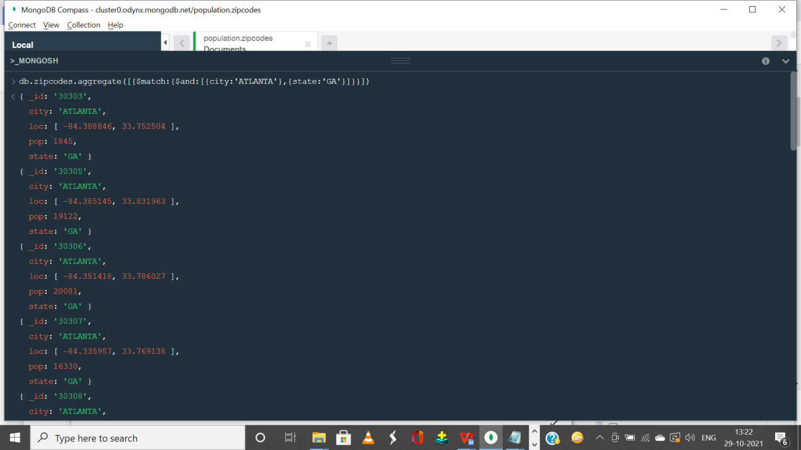

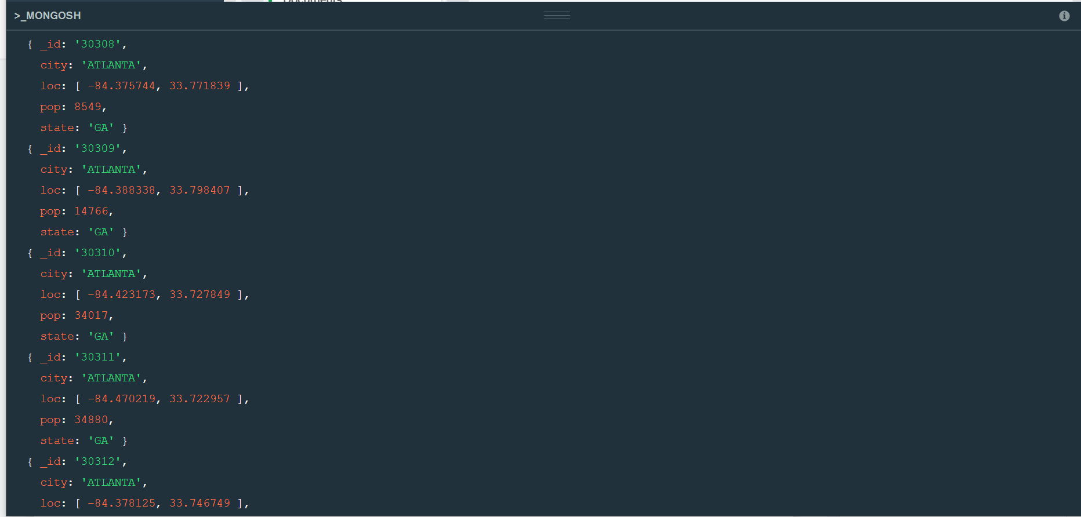

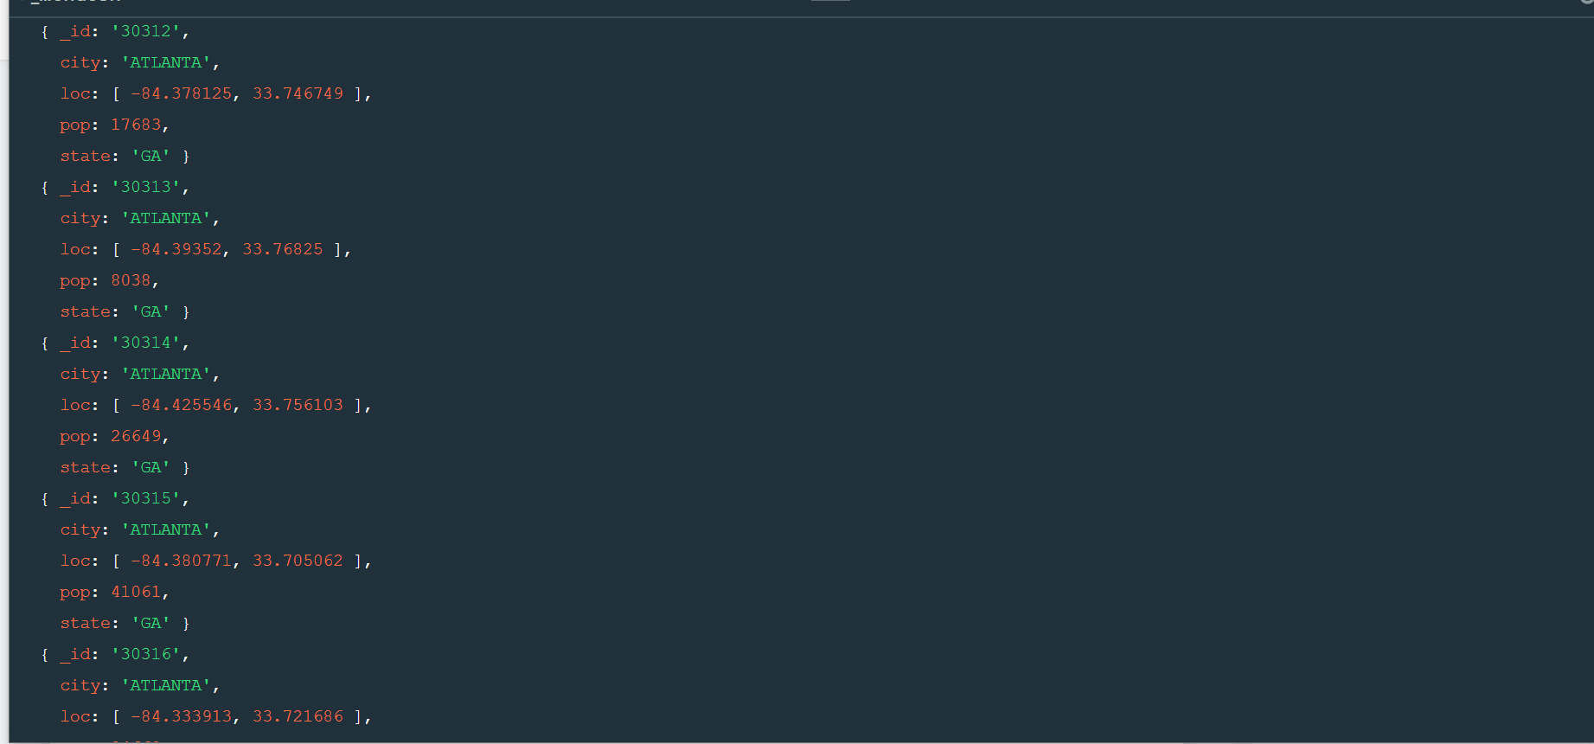

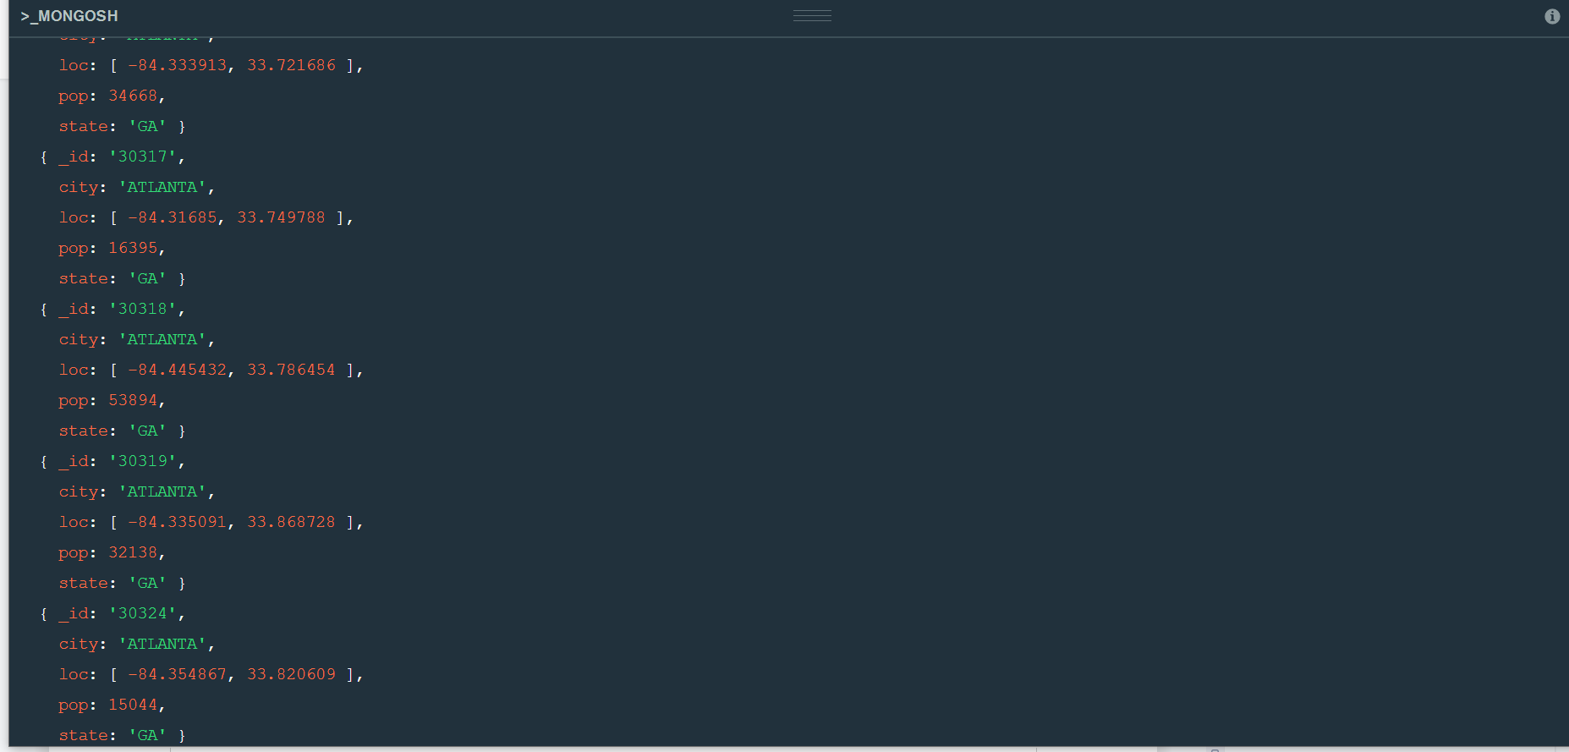

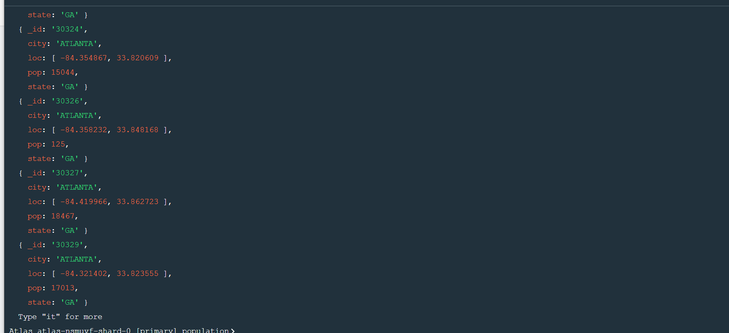

1. use $group to count the number of zip codes in Atlanta.

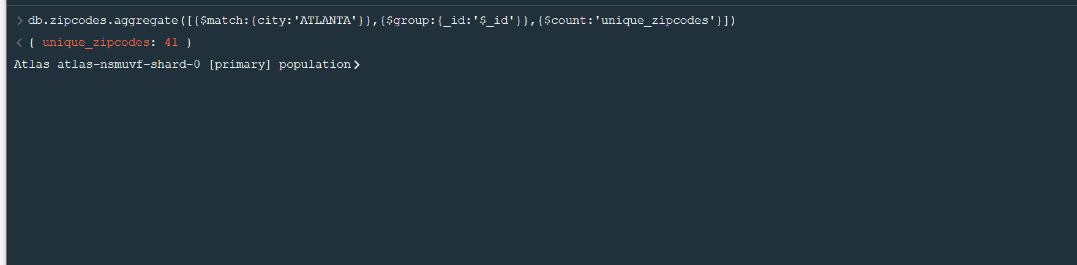

1. use $group to find the total population in Atlanta.

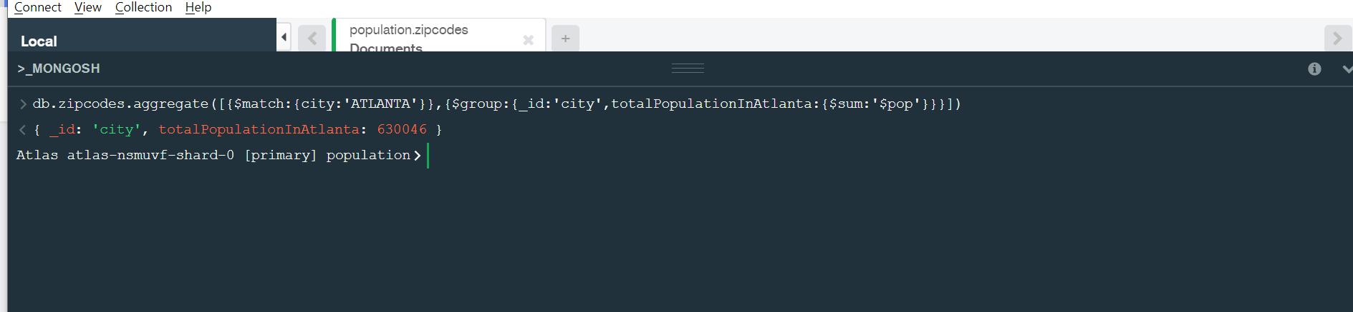

# Populations By State

1. use aggregate to calculate the total population for each state

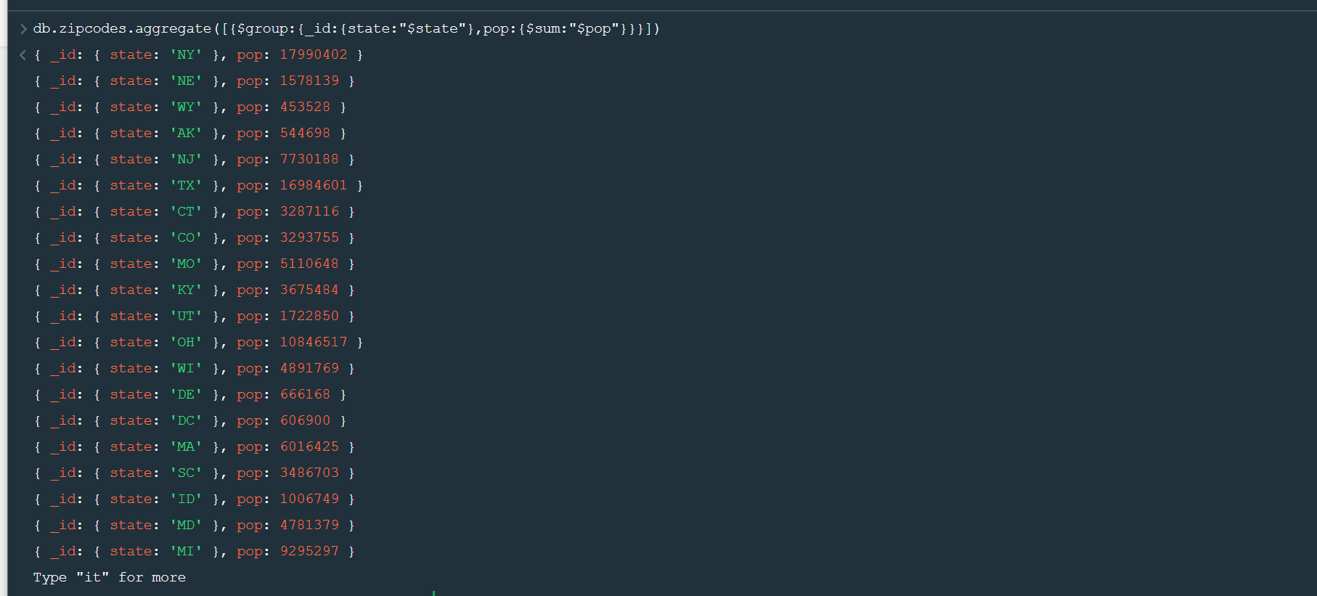

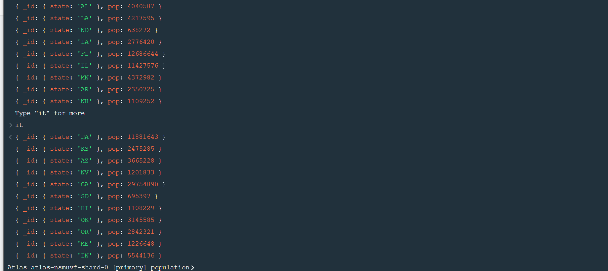

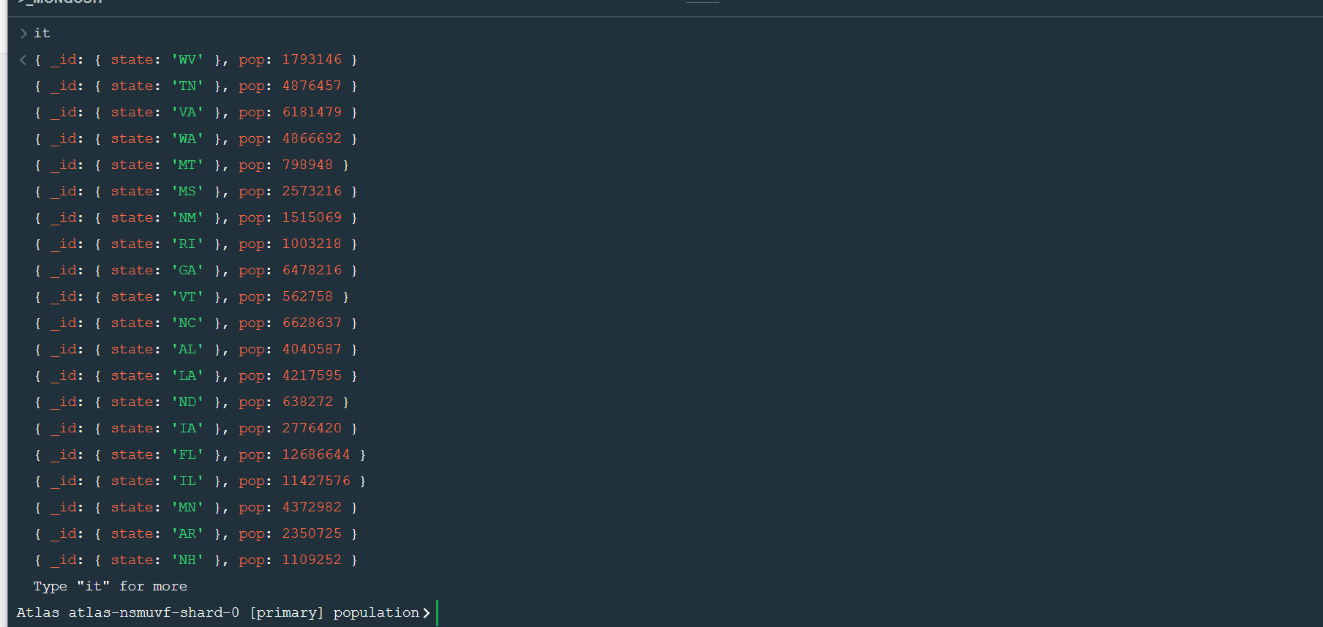

1. sort the results by population, highest first

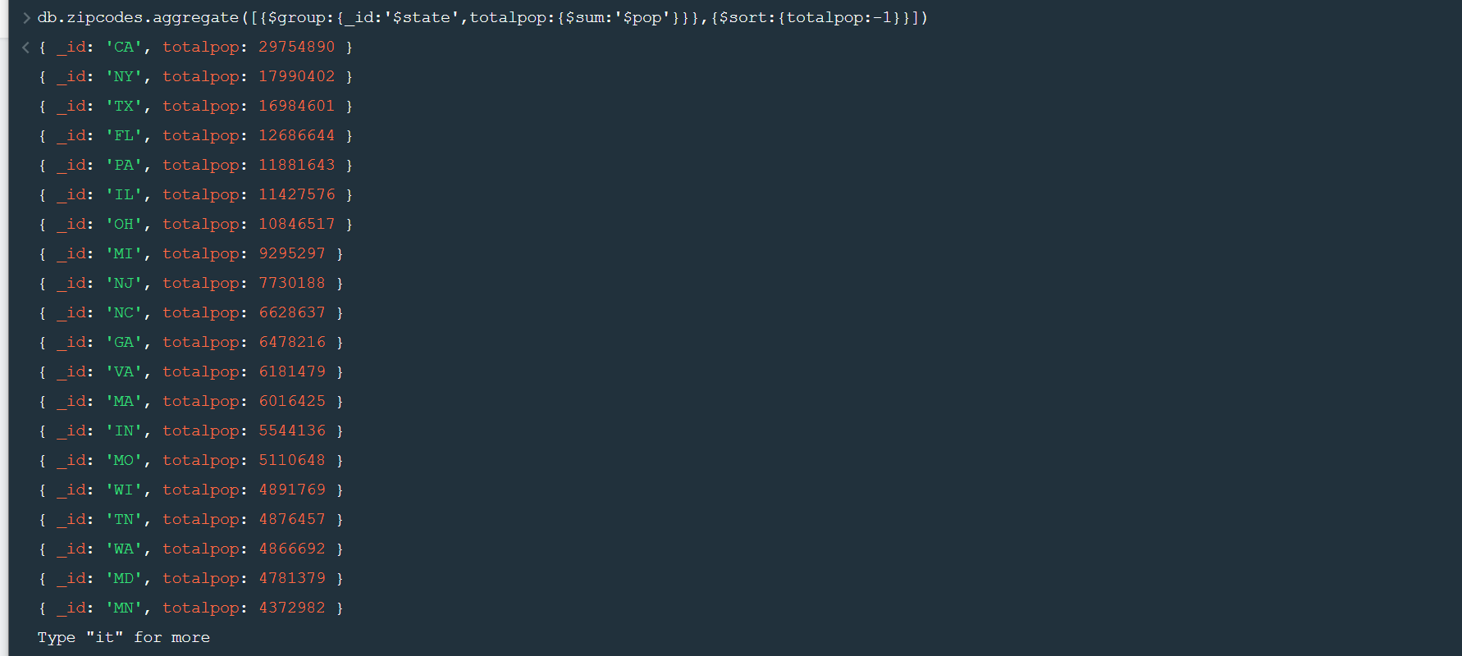

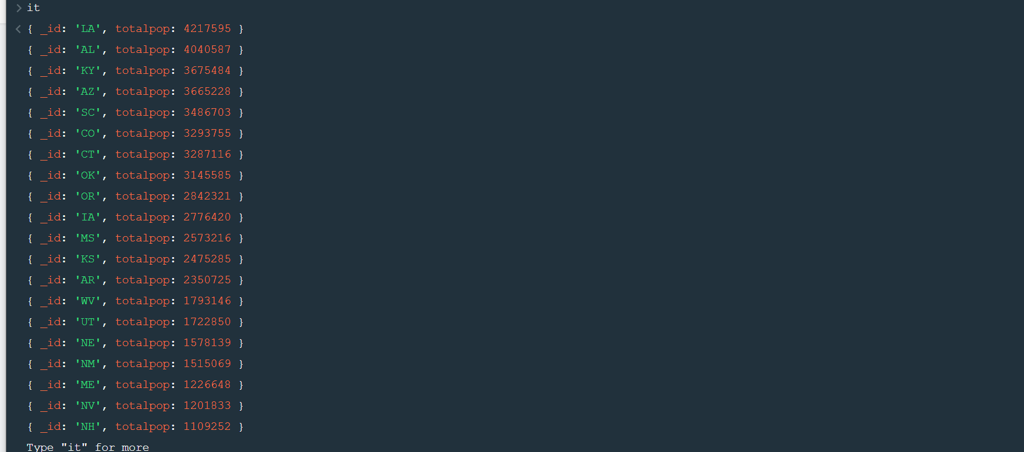

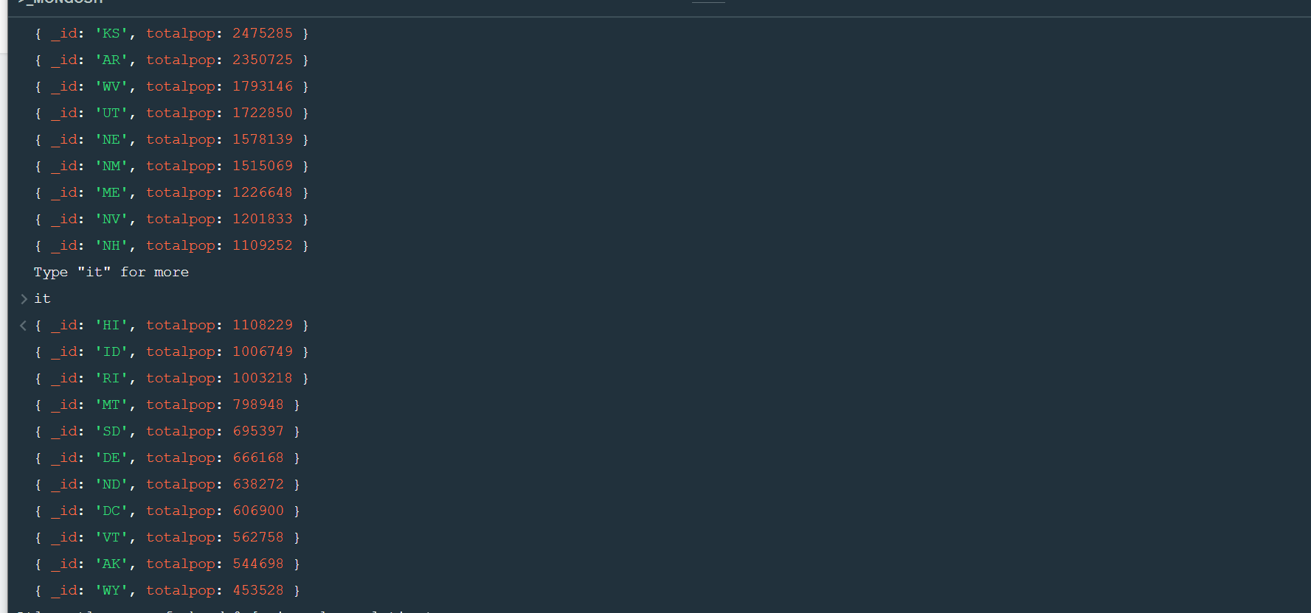

1. limit the results to just the first 3 results. What are the top 3 states in population?

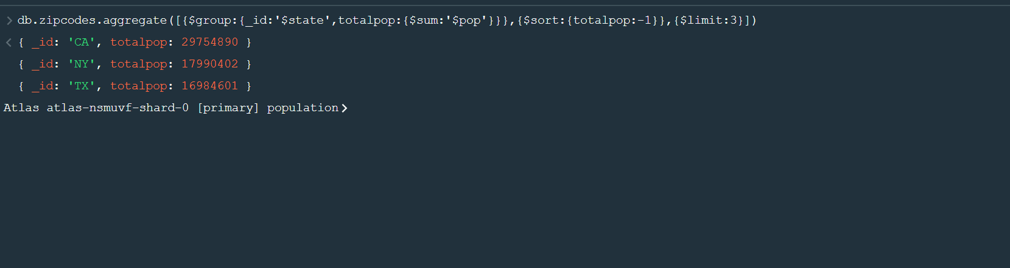

# Populations by City

1. use aggregate to calculate the total population for each city (you have to use city/state combination). You can use a combination for the _id of the $group: { city: '$city', state: '$state' }

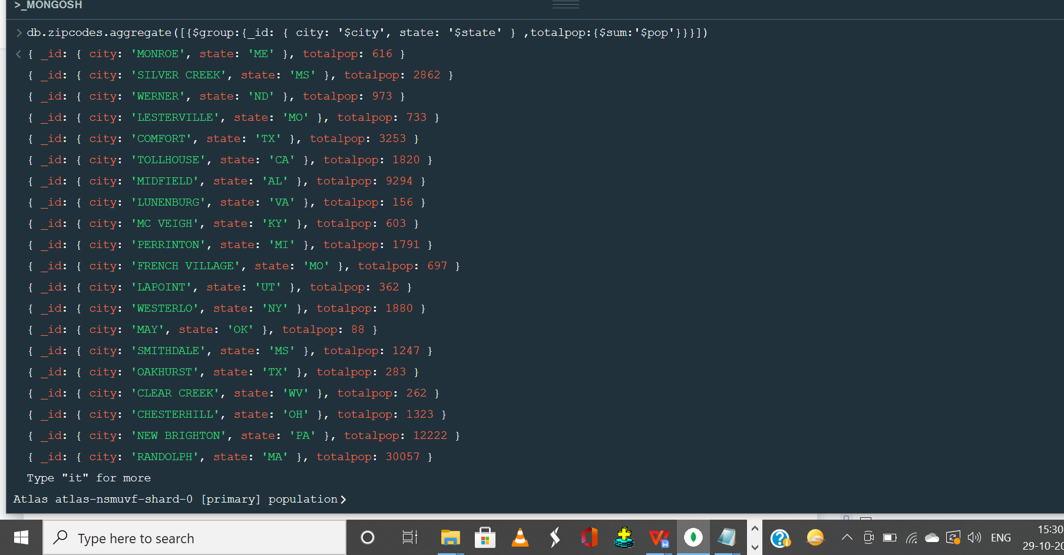

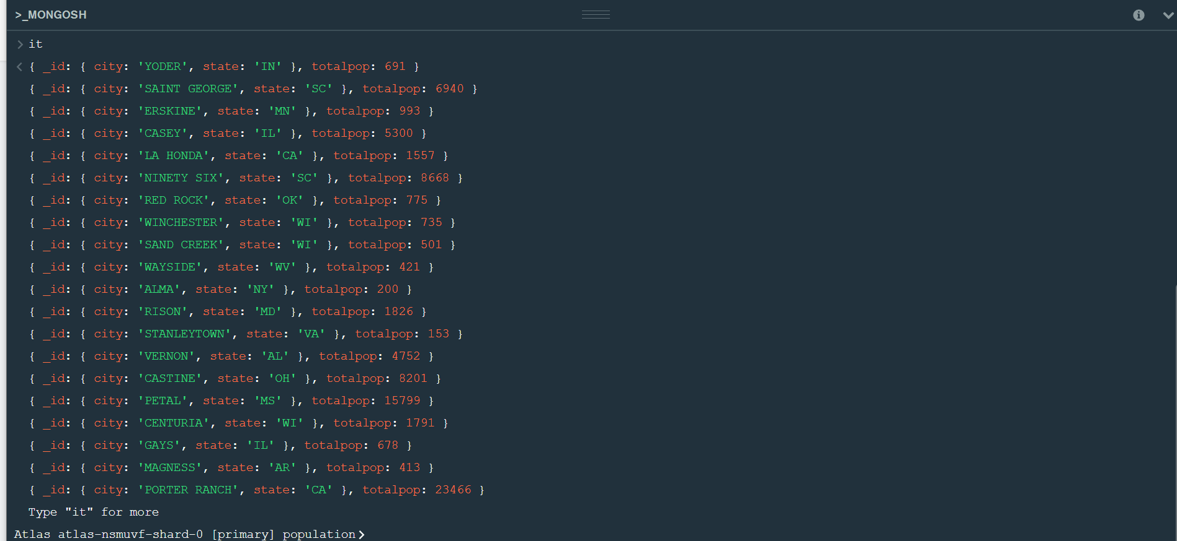

1. sort the results by population, highest first

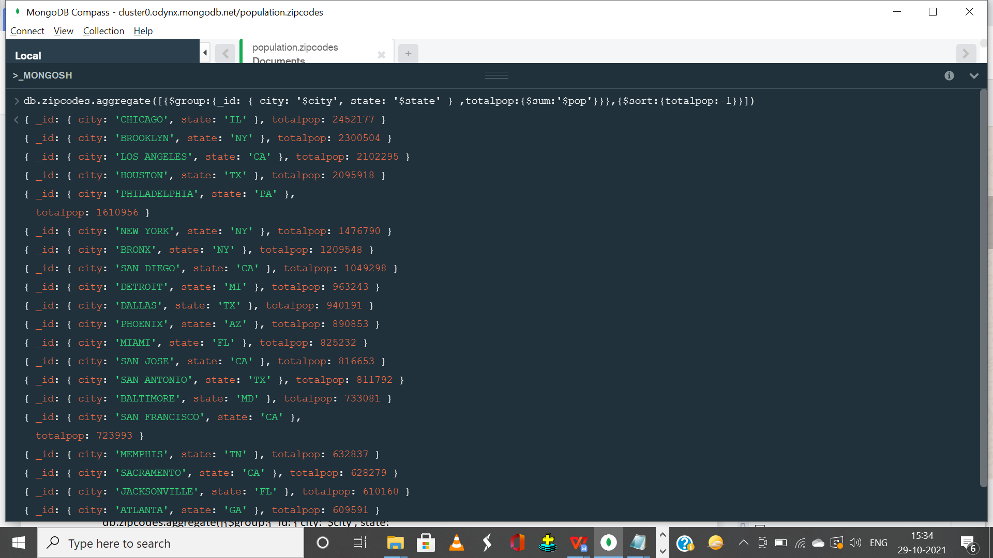

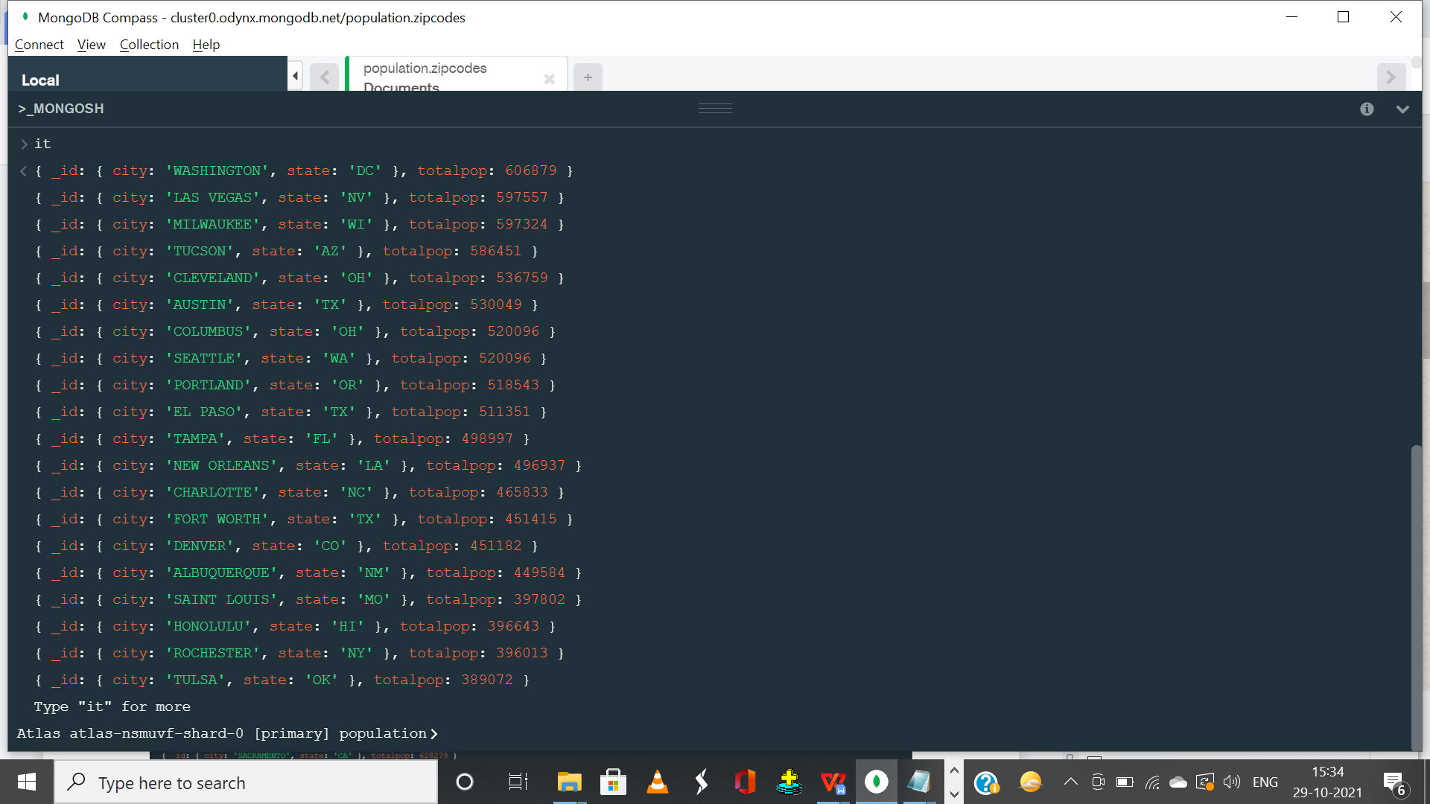

1. limit the results to just the first 3 results. What are the top 3 cities in population?

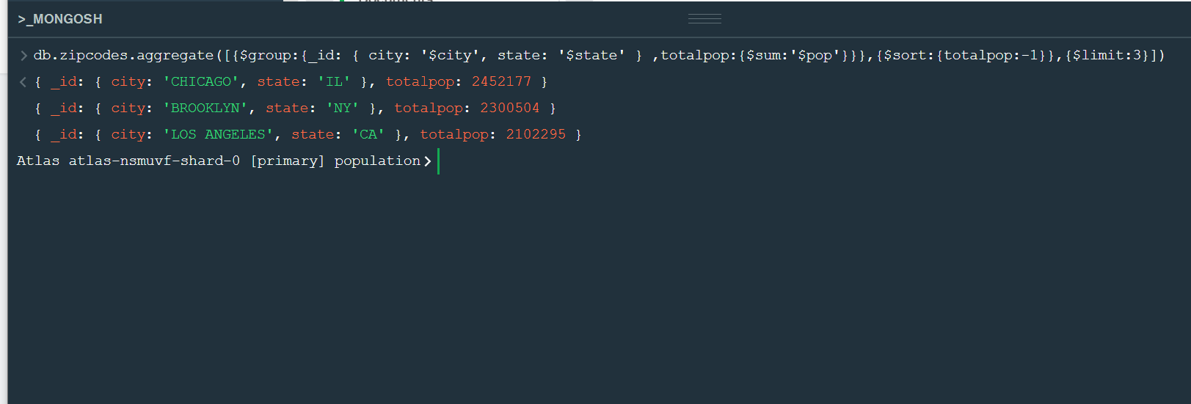

1. What are the top 3 cities in population in Texas?

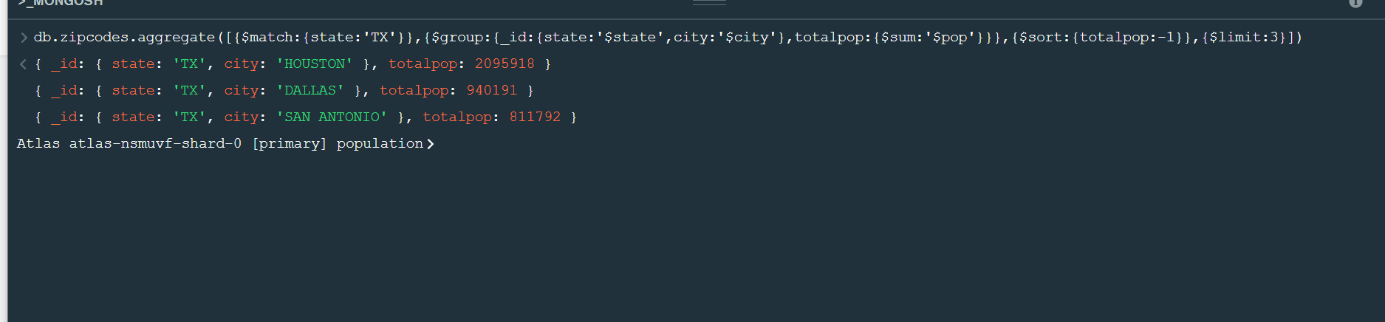

# Bonus

1. Write a query to get the average city population for each state.

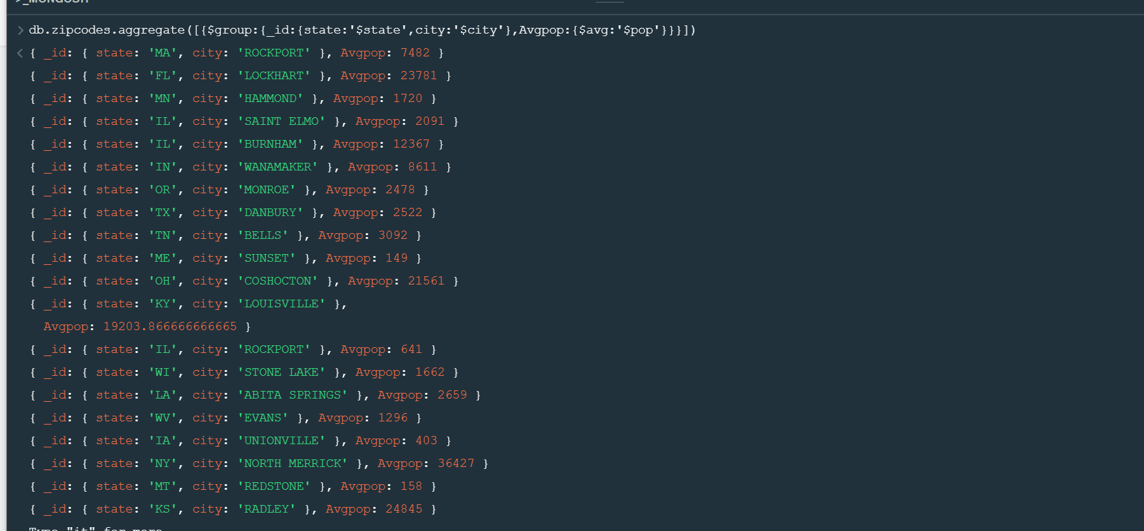

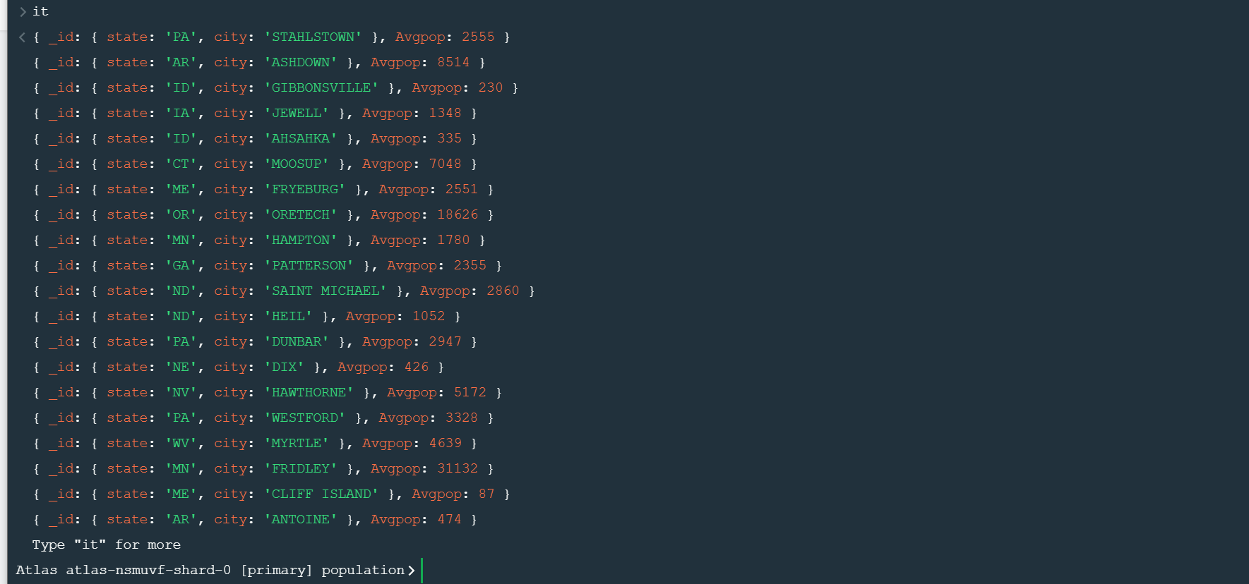

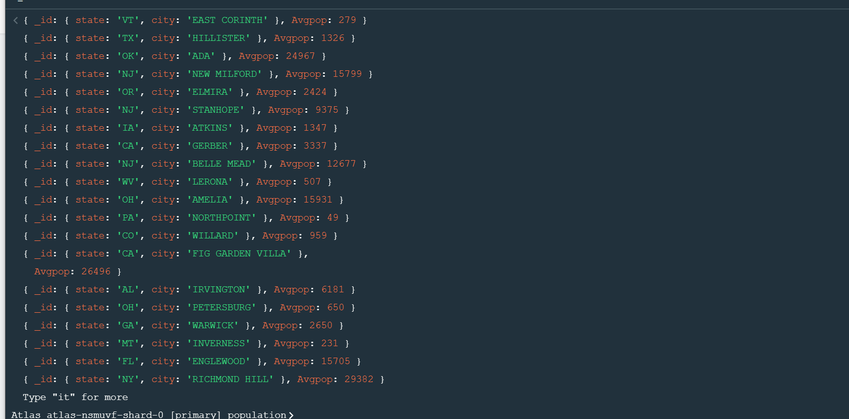

1. What are the top 3 states in terms of average city population?

